Test Paper No _____

APPLECROSS SENIOR HIGH SCHOOL

3A 3B HUMAN BIOLOGICAL SCIENCE

DO NOT MARK THIS TEST PAPER IN ANY WAY

Time allowed: 30 minutes.

Answer questions 1 to 30 on the multiple choice answer sheet. Follow the instructions on the answer sheet.

___________________________________________

Question 1 refers to the x-ray image shown below.

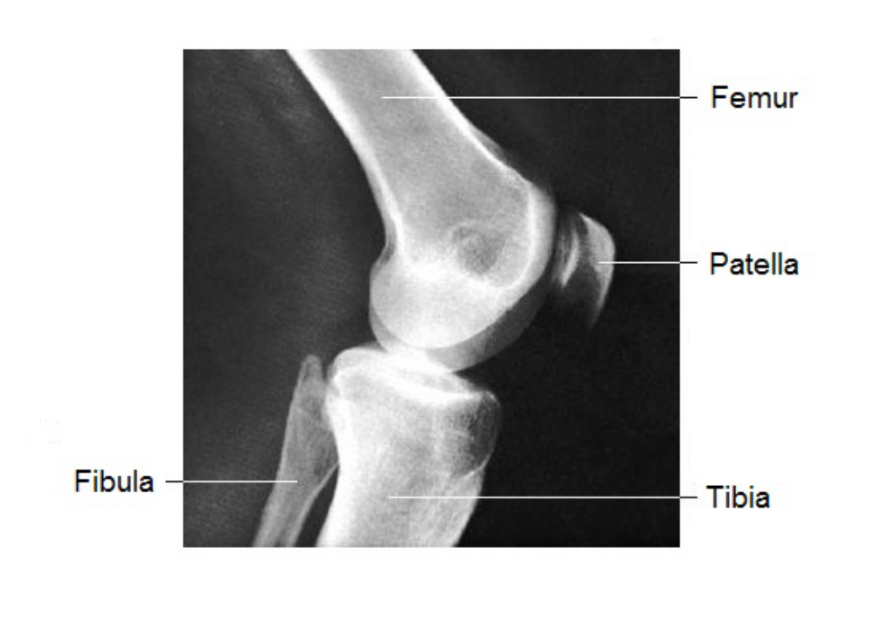

1. The joint shown in the x-ray is an example of a/an
(a) ball and socket joint.
(b) gliding joint.
(c) immovable joint.
(d) hinge joint.

Question 2 refers to the diagram shown below.
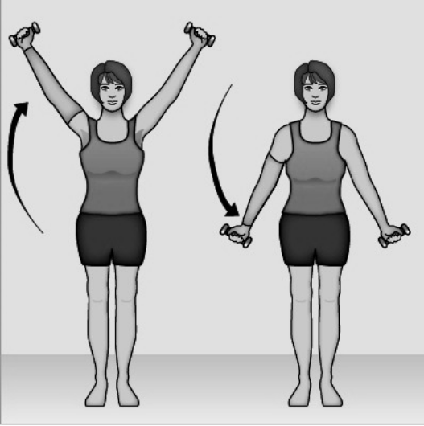

2. The movement of the arms shown in the diagram is an example of
(a) abduction and adduction controlled by the muscles of the upper arm.
(b) flexion and extension controlled by the muscles of the neck and upper back.
(c) abduction and adduction controlled by the muscles of the shoulder and chest.
(d) flexion and extension controlled by the muscles of the upper and lower arm.

3. According to the sliding ﬁlament mechanism of skeletal muscle contraction, during contraction:

a) The thick ﬁlaments stay the same size but the thin ﬁlaments shorten.
b) The sarcomeres shorten.
c) The thin ﬁlaments stay the same size but the thick ﬁlaments shorten.
d) Both thick and thin ﬁlaments shorten.

4. The basic structural and functional unit of skeletal muscle is the

a) ﬁbre
b) fascicule
c) myoﬁbril
d) sarcomere

5. Actin myoﬁlaments

a) are attached to the Z line.
b) are found primarily in the H zone.
c) are thicker than myosin myoﬁlaments.
d) all of the above

6. When a person moves their arm from A to B as shown in the diagram below:
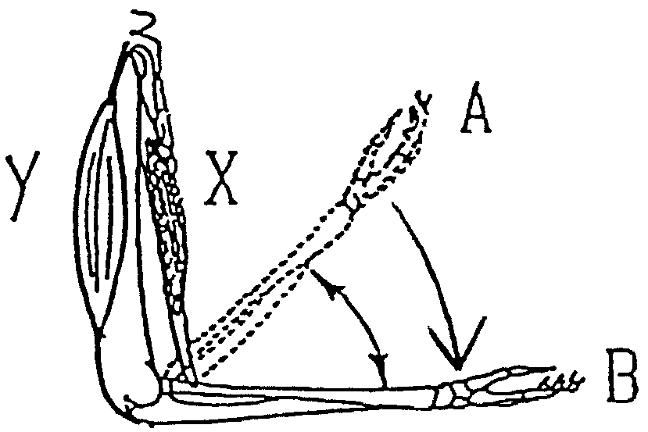

a) muscles X and Y both contract
b) muscle X contracts and muscle Y relaxes
c) muscle X relaxes and muscle Y contracts
d) muscle X and Y both relax

7. In skeletal muscle contraction, the role of calcium ions is very important. The internal
cellular structure that stores calcium is called the
(a) mitochondrion.
(b) motor end plate.
(c) microfilament.
(d) sarcoplasmic reticulum.

8. Turning on a bathroom tap requires the

(a) abduction of the arm.
(b) adduction of the arm.
(c) circumduction of the arm.
(d) rotation of the arm.

9. Which grouping of muscle constituents is listed correctly in descending order of size?

a) myoﬁbril, muscle ﬁbre, myoﬁlament
b) muscle ﬁbre, myoﬁbril, actin-myosin, myoﬁlament
c) muscle fibre, myoﬁbril, myoﬁlament
d) muscle ﬁbre, myoﬁbril, myoﬁlament, actin-myosin

10. Cartilage

a) is made up of haversian systems.
b) provides points of attachment for muscles.
c) contains fibres of collagen to provide strength and flexibility.
d) contains blood vessels which speeds its rate of healing.

11. Which of the following is NOT a function of muscle?

a) Maintaining posture
b) Movement
c) Generating heat
d) Producing red blood cells

12. Smooth muscle is different to skeletal muscle in that smooth muscle

a) is under involuntary control.
b) does not require ATP for muscle contractions to occur.
c) receives impulses from the somatic nervous system to initiate contraction.
d) does not involve the sliding filament model.

13. Yellow bone marrow

a) provides internal support to spongy bone
b) is found only in lower vertebrates
c) produces red blood cells
d) stores fat

14. Which type of muscle is labelled III in the Venn diagram shown

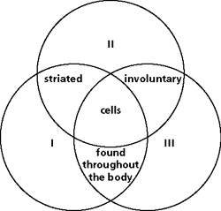

a) smooth
b) ﬁlament
c) skeletal
d) cardiac

15. Movement at a joint away from the midline is known as _____________, and movement towards the midline is _____________.

a) ﬂexion; extension
b) extension; ﬂexion
c) adduction; abduction
d) abduction; adduction

16. Bones are covered with a dense white connective tissue called _________________.

a) diaphysis
b) endosteum
c) periosteum
d) epiphysis

17. Which of these is NOT a normal function of the skeleton?

a) mineral storage
b) protection of underlying tissues
c) production of red blood cells
d) All of these are functions of the skeleton.

18. Each osteon contains:

a) lamellae
b) a central canal
c) osteocytes in lacunae.
d) all of these

19. Cancellous bone

a) has no osteocytes.
b) is mainly located in the diaphyses of long bones.
c) is composed of delicate interconnecting rods or plates.
d) has spaces filled with marrow.

20. Straightening your arm to point at something straight ahead of you involves

a) abduction of the arm.
b) adduction of the arm.
c) circumduction of the arm.
d) extension of the arm.

21. What is the name of the attachment that binds one bone to another?

a) ﬁlament
b) joint
c) tendon
d) ligament

22. A good example of a positive feedback mechanism would be

a) body temperature regulation.
b) regulating glucose levels in the blood.
c) enhancement of labor contractions by oxytocin.
d) blood calcium level regulation.

23. How is the control of cardiac muscle unique?

a) It is not affected by the action of hormones.
b) It can initiate its own contractions.
c) It only involves nervous control.
d) It is controlled by adrenalin.

24. The _____ represent the cracks in bone tissue that directly supply nutrients to the osteocytes.

a) canaliculi
b) lamellae
c) osteons
d) Haversian canals

25. The shoulder and hip joints are of this type.

a) ball-and-socket
b) pivot
c) saddle
d) gliding

26. The type of joint that is distinguished by having a fluid-filled joint cavity is a ______________ joint.

a) ﬁbrous
b) cartilaginous
c) synovial
d) suture

27. Within certain synovial joints, fibrous cartilaginous pads, called ______________, cushion and guide the articulating bones.

a) articular cartilages
b) bursae
c) synovial membranes
- menisci

28. The greatest range of motion is provided by the

a) pivot joint
b) ball-and-socket joint
c) saddle joint
d) condyloid joint

29. Which one of the following body joints is bathed in synovial fluid?

a) plates of bone that make up the skull
b) tooth sockets.
c) between the third rib and the sternum.
d) between finger phalanges

30. The joints between the phalanges are ________ joints.

a) gliding
b) hinge
c) pivot
d) condyloid

PART B
Written Section: Answer Questions 31 to 33 on the paper provided. Do not mark this paper.

31. Name the parts of the long bone indicated on the diagram below.
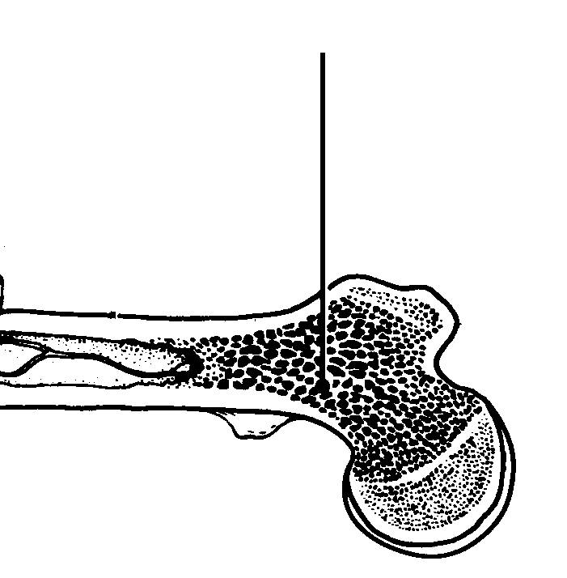
D
C

B

E

F
A

(3 marks)
A___________________________________
B___________________________________
C___________________________________
D___________________________________
E___________________________________
F___________________________________

32. (a) Differentiate between the structure and function of skeletal and smooth muscle. (4 marks)
__________________________________________________________________________
__________________________________________________________________________
__________________________________________________________________________
__________________________________________________________________________
__________________________________________________________________________
__________________________________________________________________________

(b) State the role of calcium, acetylcholine and ATP in the sliding filament theory of muscle action. (3 marks)
__________________________________________________________________________
__________________________________________________________________________
__________________________________________________________________________
__________________________________________________________________________
__________________________________________________________________________
__________________________________________________________________________

(c) The diagram below shows the sequential action of the muscles of the right leg when starting to run a race.

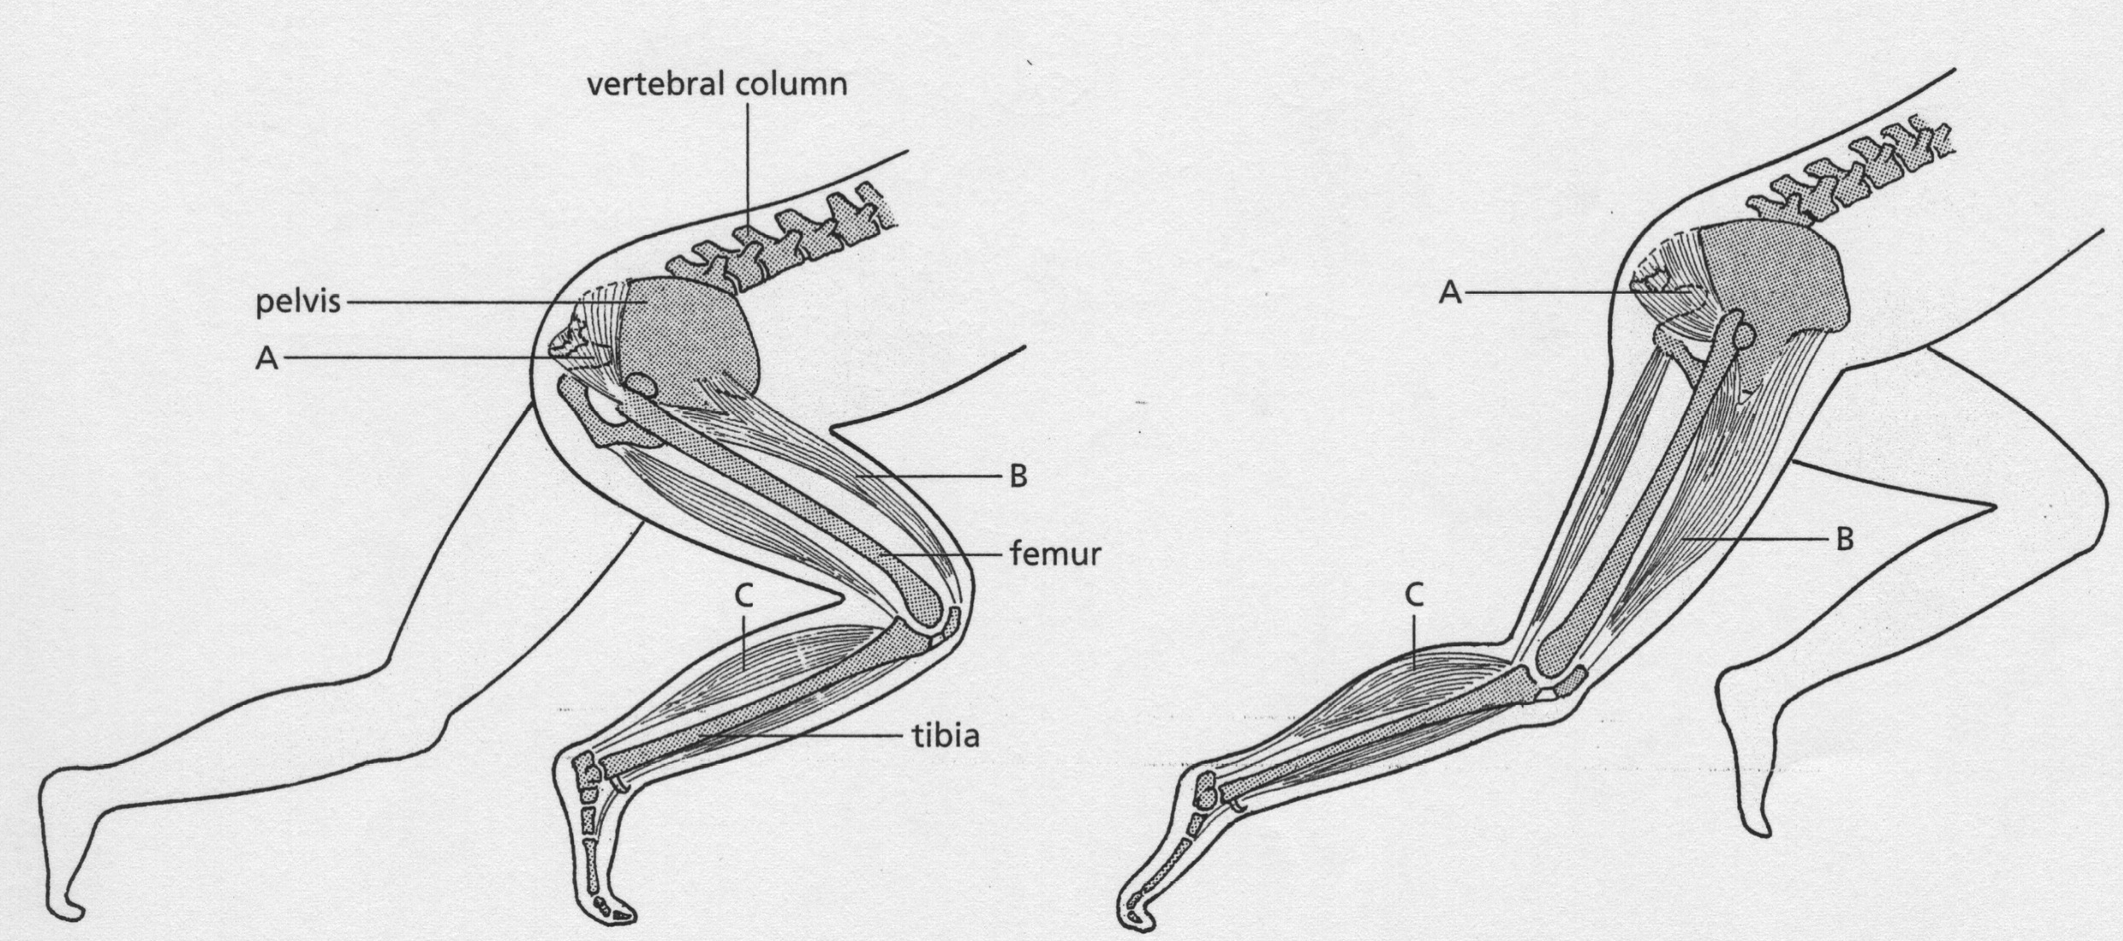
Position One Position Two

(i) What action is taking place in muscle B to get to Position Two? (1 mark)
__________________________________________________________________________
(ii) Label muscle B’s antagonist with an X on the diagram. (1 mark)
(iii) How do the joints at the two ends of the femur differ? (2 marks)
__________________________________________________________________________
__________________________________________________________________________
__________________________________________________________________________
__________________________________________________________________________
(iv) State the protective mechanisms available at the knee joint. (4 marks)
__________________________________________________________________________
__________________________________________________________________________
__________________________________________________________________________
__________________________________________________________________________
__________________________________________________________________________
__________________________________________________________________________

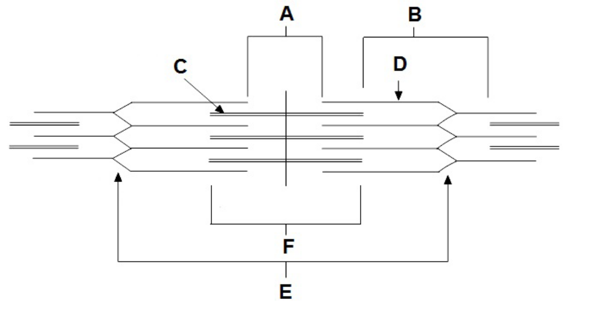
33.

(a) Identify the structures labelled A and B. (2 marks)
A: ___________________________________________
B: ________________________________________________

(b) State the function of the structures labelled C and D. (2 marks)
C: ____________________________________________________________________
_______________________________________________________________________

D:_____________________________________________________________________
_______________________________________________________________________

(c) There are two types of bone marrow in a long bone: red and yellow. How do they differ
in function? (2 marks)
_______________________________________________________________________
_______________________________________________________________________
_______________________________________________________________________
_______________________________________________________________________

(d) Suggest why the density of bone in a long bone needs to differ between the epiphysis
and diaphysis. (2 marks)
_______________________________________________________________________
_______________________________________________________________________
_______________________________________________________________________
_______________________________________________________________________

(e) Osteoporosis and osteoarthritis are both degenerative bone diseases that can be
associated with ageing.
Distinguish between osteoporosis and osteoarthritis and state one medical technology
that is currently available for the treatment of each of these diseases. (4 marks)

_______________________________________________________________________
_______________________________________________________________________
_______________________________________________________________________
_______________________________________________________________________

